Service Asset Maintenance

# Features & Concepts

1. Kendo UI
2. MVVM
3. Phone and Tablet layout
4. Localization
5. Camera
6. Barcode scanner
7. Location
8. Google maps API
9. Telerik Analytics
10. Telerik Feedback (Android & iOS)
11. Telerik Backend Services

# User Interface

## Login

The user have to login the first time he/she uses the application. Next time the application logs him/her automatically until the authentication token expires.

## Register

Creates new user.

## Password Recovery

User can recover his/her password.

## Home Screen

Shows all Service Requests. This screen has two different layouts depending on the device (phone or tablet).

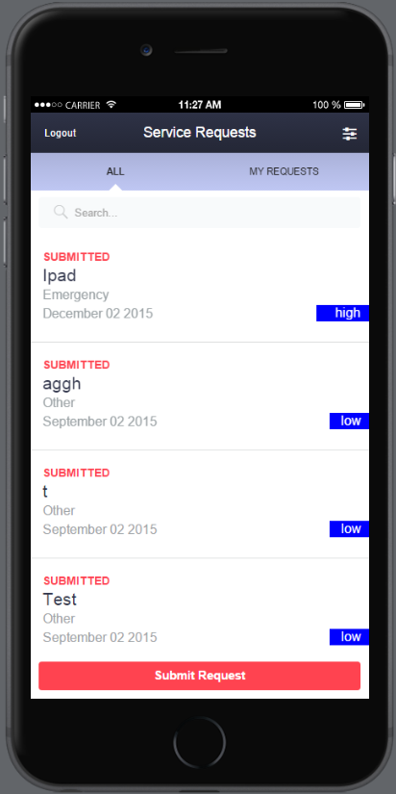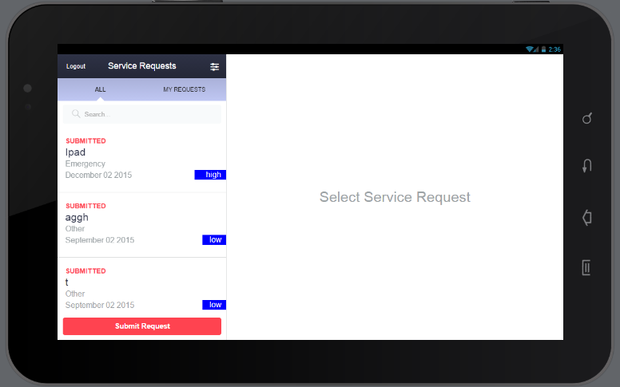

### Home Screen Filter

Users can refine the way Service Requests are displayed. They can filter them by Priority and Maintenance Type. Users can sort the results by Due Date, Priority, Date Created or Date Completed. They can filter only their requests, as well as search for a specific criteria.

## Service Request Details

Shows details for a selected service request. Every Service Request can be canceled.

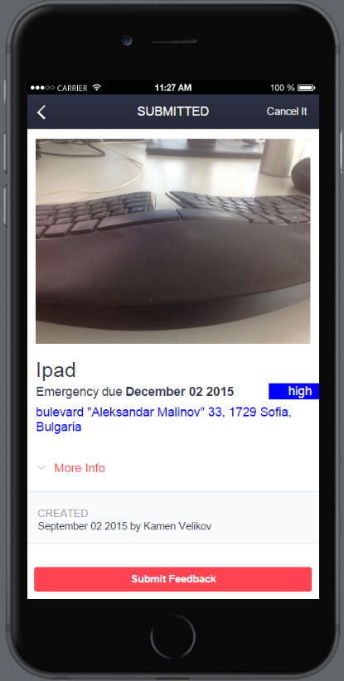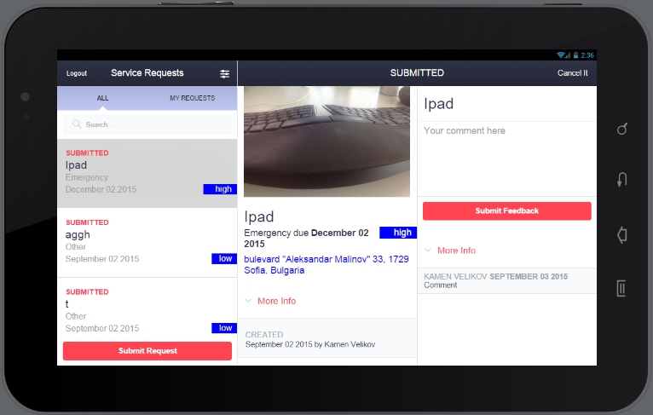

## Feedback

Users can view and submit feedback for every Service Request.

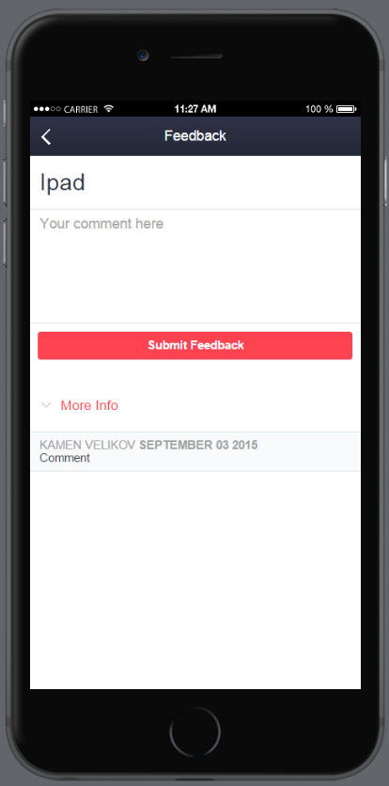

## Submit Service Request

Users can submit new service requests. They can attach picture, scan barcode (in the simulator instead of barcode scanner application shows list with predefined asset numbers). The application saves the geolocation and address where the request is submitted.

